**Name – Parag Gattani**

Program No. – 12

Program Title – Tilt Sensor

**AIM**

Design a Smart Package handling system (Tilt sensor and LED)

**HARDWARES REQUIRED**

* Arduino Board, Breadboard Small
* LEDs, Tilt Sensor, Resistor

**CIRCUIT DIAGRAM**

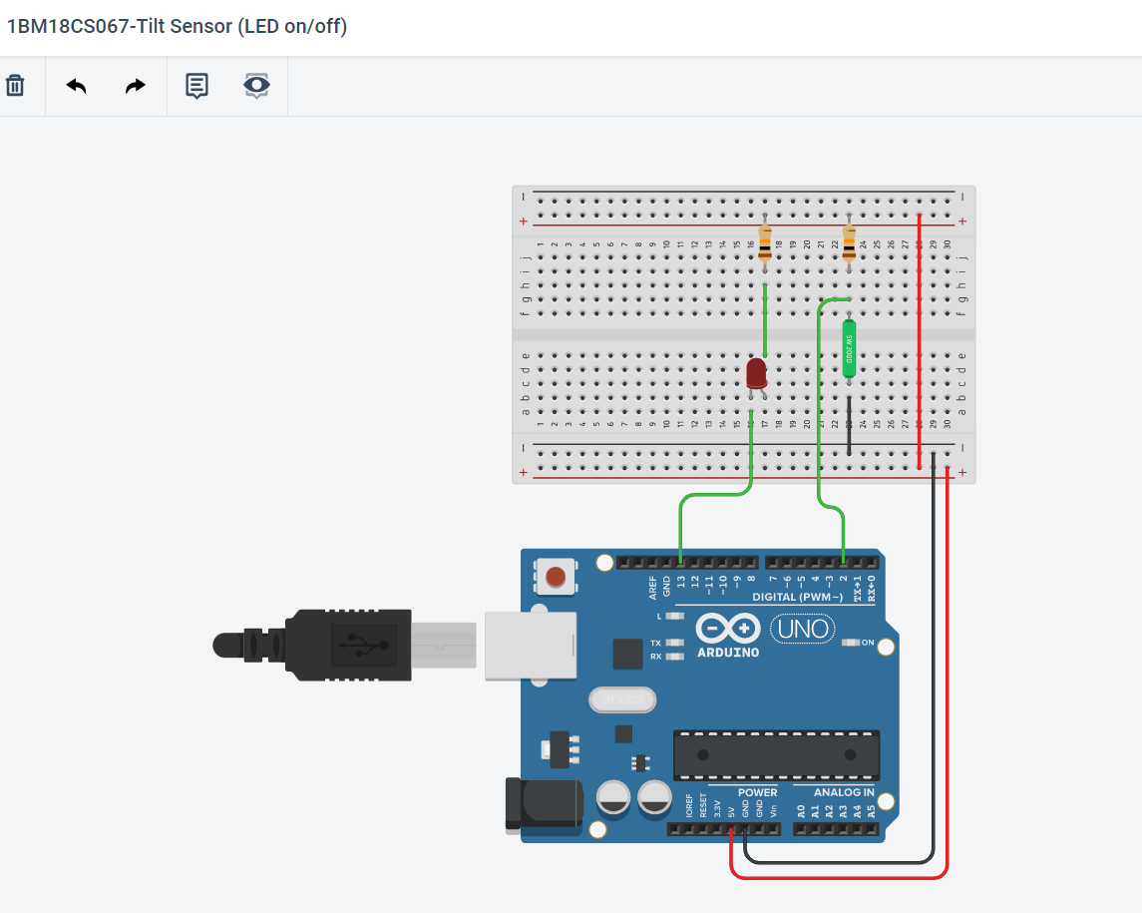

**WRITE-UP**

**CODE**

int tilt = 2;

int led = 13;

void setup()

{

pinMode(tilt, INPUT);

pinMode(led, OUTPUT);

}

void loop()

{

int reading;

reading = digitalRead(tilt);

if(reading)

digitalWrite(led, LOW);

else

digitalWrite(led, HIGH);

}

**OUTPUT**

Designed a Smart Package handling system using Tilt Sensor and LED.